A000-MEX-Olmec-Jar-Ceramic-Hieroglyphs-1100 BCE

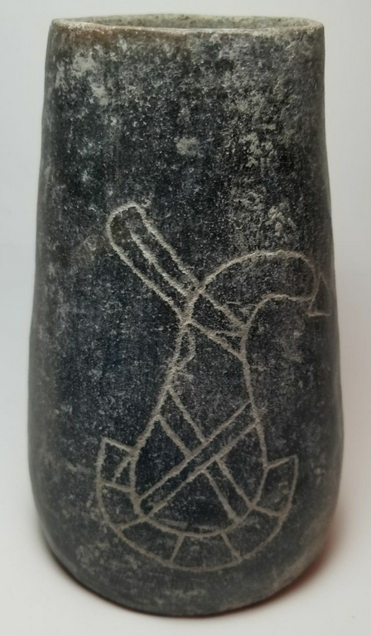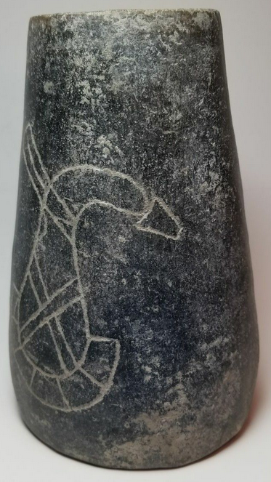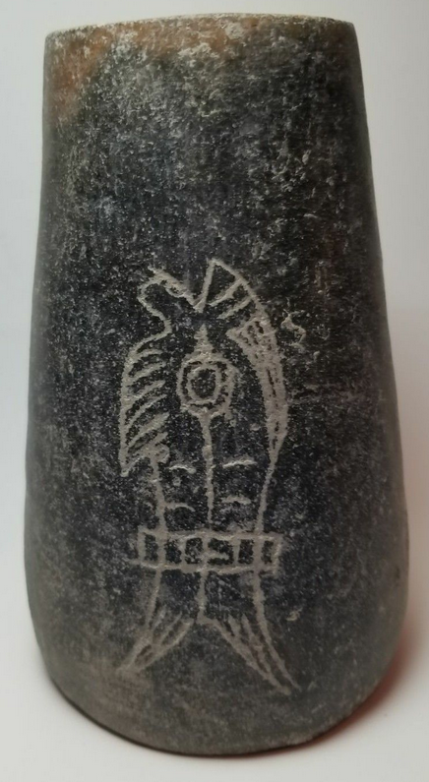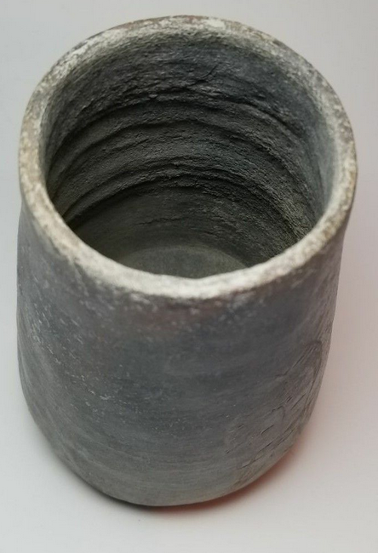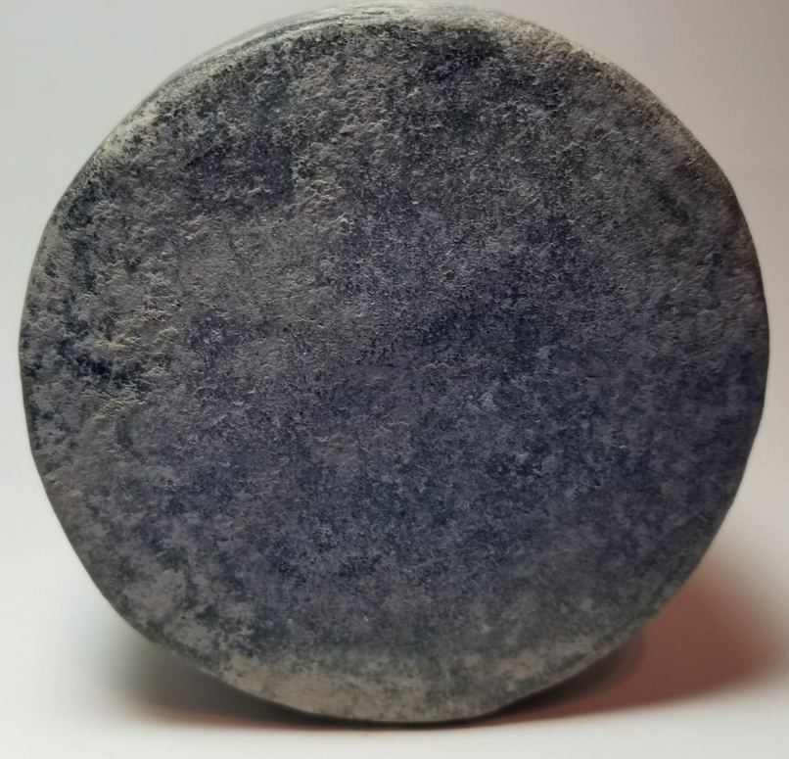

Figs. 1-5. Olmec-Jar-Ceramic-Hieroglyphs-1100 BCE

**Case No.: 10**

**Accession No.**

**Formal Label:** Olmec-Jar-Ceramic-Hieroglyphs-1100 BCE

**Display Description:**

This Olmec jar with two complex hieroglyphs was discovered in the Veracruz lowlands of coastal southeastern Mexico near where the Cascajal Block was discovered in the village of Lomas de Tacamichapan following road building. This suggests that the two finds relate to the same hitherto unknown Olmec writing system.

 

Fig. 6. The first glyph on the Olmec jar. Fig. 7. The first Olmec jar’s glyph elements.

 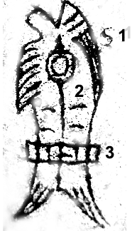

Fig. 8. The second glyph on the Olmec jar. Fig. 9. The second Olmec jar’s glyph elements.

**Accession Number:**

**LC Classification:**

**Date or Time Horizon:**

**Geographical Area:**

**Map:**

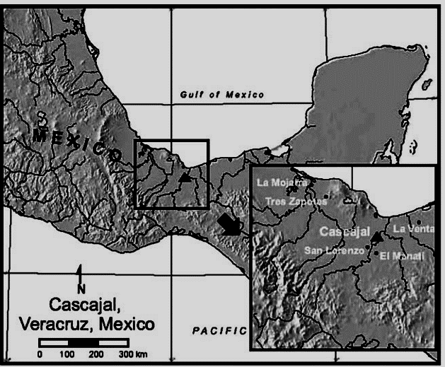

**Fig. 10. Map of Mexico showing location of Cascajal in Veracruz.**

**GPS coordinates:**

**Cultural Affiliation:**

**Media:**

**Dimensions:**

**Weight:**

**Condition:**

**Provenance:**

**Discussion:**

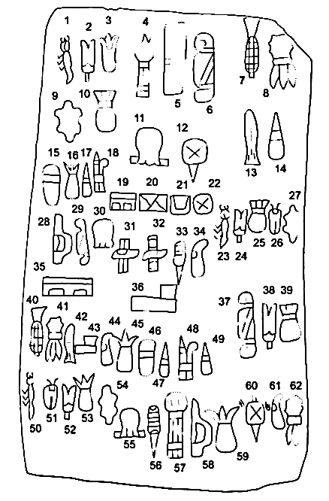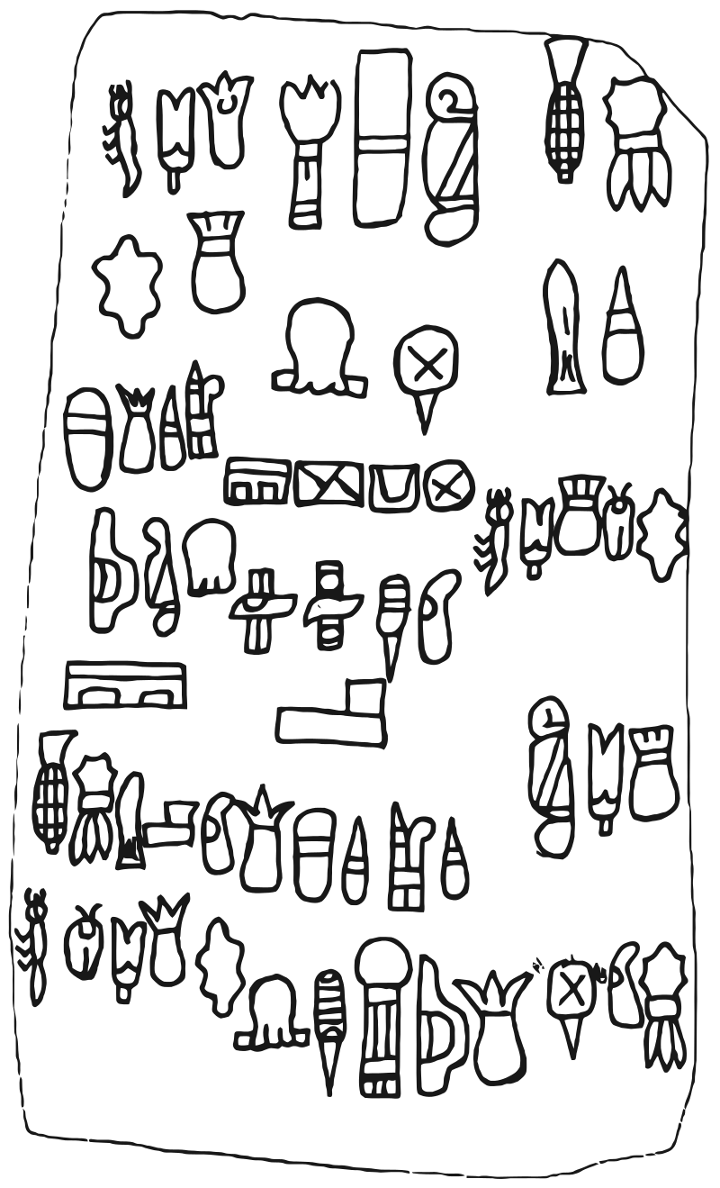

The Cascajal block .

Debris surrounding the block included shards and clay figurines that provide dating for the finds to dated to the Olmec [archaeological culture](https://en.wikipedia.org/wiki/Archaeological_culture)'s [San Lorenzo Tenochtitlán](https://en.wikipedia.org/wiki/San_Lorenzo_Tenochtitl%C3%A1n) phase, which ended c. 900 BCE, preceding the oldest [Zapotec](https://en.wikipedia.org/wiki/Zapotec_civilization) writing dated to about 500 BCE. The block was found amidst ceramic.[[2]](https://en.wikipedia.org/wiki/Cascajal_Block#cite_note-2)[[3]](https://en.wikipedia.org/wiki/Cascajal_Block#cite_note-3) Archaeologists Carmen Rodriguez and Ponciano Ortiz of the [National Institute of Anthropology and History](https://en.wikipedia.org/wiki/National_Institute_of_Anthropology_and_History) of Mexico examined and registered it with government historical authorities. It weighs about 11.5 kg (25 lb) and measures 36 cm × 21 cm × 13 cm.

Text analysis. The Cascajal block conforms to all expectations of writing (Figs. 4 and 5) (9).

The text deploys

1. a signary (characters in a writing system) of about 28 distinct elements, each an autonomous, codified glyphic entity;
2. (ii) a few in repeated, short, isolable sequences within larger groupings; and
3. (iii) a pattern of linear sequencing of variable length, with
4. (iv) a consistent reading order.
5. As products of a writing system, the sequences would by definition reflect patterns of language, with the probable presence of syntax and language-dependent word order (10).
6. Text orientation is clear.
7. Olmec imagery consistently displays vegetal icons, which sprout to the top.
8. The appearance of such signs in the text demonstrates that the inscription is horizontal.
9. This orientation is further supported by the disposition of ‘‘sky-band’’ elements much like those on Olmec thrones and later regional iconography.
10. Reading order is more difficult to establish. Most Mesoamerican scripts read left to right in unmarked conditions, i.e., when not arranged in unusual architectural settings. Left to right is likely to be present here, too.
11. Yet, there is no strong evidence of overall organization. The sequences appear to be conceived as independent units of information, although to judge from shared details of carving they were recorded by the same hand.
12. The signary is likely to be incomplete. Three signs appear four times, six appear thrice, 12 occur twice, and seven occur once.
13. The Cascajal block has three two-part sequences: sign 4 plus sign 1; sign 17 plus sign 8; and, perhaps, sign 3 plus sign 19. One sign, of an apparent insect Fig. 3. Photographs of block, side and back views. Fig. 4. Epigraphic drawing of block. from positioned as though scaling upward, faces its body to the direction of reading. It clearly opens sequences. In the shorter sequences, signs do not repeat. This is not the case with the two longest sequences at the base of the text.
14. The chance of deciphering Olmec writing, that is, of linking it to language, is low. The sample is small, correlations to explanatory imagery are absent in the Cascajal block, and the restricted number of signs, although pointing by their small quantity to an alphabet, is potentially a meaningless statistic.
15. With new finds there remains a strong chance of notable increments in the signary, as has proved true for the undeciphered Isthmian writing found not far from Cascajal (11). It is evident that some of the signs have an iconic origin, a few more transparent than others. The paired sets of eyes in signs 24 and 25 suggest the facial markings seen on some Olmec celts of the Middle Formative period [figure 44 in (12)]. Several paired sequences, such as the eyes or a throne sign paired with an evident mat sign, both common tropes for rulership in Mesoamerica, point to poetic couplets that are otherwise well attested in formal discourse of the region [figure 11 in (13), (14)].
16. If valid, the Cascajal examples would illustrate the earliest known couplets in Mesoamerica, a feature not yet seen in other Olmec icons. Signs 12, 17, and 27 show a thematic preoccupation with maize, or at least the ready use of such signs in the creation of a signary. Sign 6 may be a skin; sign 8, a strung bead or plaque; sign 10, a dart tip; sign 16, an object shown grasped in Olmec iconography; sign 18, a bivalve; sign 20, a possible perforator; and sign 21, a vertical fish.
17. As for dating, iconographic parallels indicate that the Cascajal block is best assigned to the transition between the Early and Middle Formative period (1000 to 800 BCE).
18. Signs 12, 16, and 20 appear in Early Formative graphs of San Lorenzo, but sign 1, with cleft element and inverted V motif, serves as a diagnostic element of Middle Formative imagery [figure 12 in (15)].
19. Similar signs occur on figurines at Canto´n Corralito, Chiapas, Mexico, but even earlier, at 1150 to 1000 BCE in uncalibrated dates [figure 3 in (16)]. The Corralito finds are especially relevant. They were excavated after the recovery of the Cascajal block, lending further weight to the general dating and validity of the text.
20. The significance of the find depends on whether more examples can be recovered and whether these can be salvaged by archaeologists rather than road builders, as regrettably occurred at Cascajal.
21. It is probable that the Tlaltenco Celt and possibly the Humboldt Celt, both from Mexico, record the same script, also disposed in horizontal sequence [figures 32 and 34 in (17)].
22. The discovery of a rich inventory of wooden sculptures nearby, at El Manatı´, of slightly earlier date, suggests that a dearth of texts today may be misleading (18). A tradition of coeval woodworking suggests an ancient reality of abundant wooden inscriptions, of which few would survive in tropical conditions.
23. The small number of texts in Isthmian writing, found also in Veracruz as well as into Chiapas, Mexico, proves that a robust, widely spread script could exist without leaving many examples that last to the present.
24. The position of the Cascajal block in the development of New World writing, and particularly in Mesoamerica, is difficult to establish. The Cascajal script bears no secure links to later Isthmian writing, which has a quite distinct signary although also from Veracruz, nor to other writing systems of Middle Preclassic Mesoamerica.
25. The dating of the block to the Early Formative–Middle Formative transition raises the possibility that its writing system is: (i) an isolate, devised locally, with no known successors or (ii) a widely spread script that disappeared before the advent of scripts across Mesoamerica in the middle of the first millennium BCE. The first view hints that the Cascajal block conforms to the domain of ‘‘shamanic’’ scripts devised by religious specialists, with tightly restricted, revelatory functions and limited use-span (19). Against this view is the clear linkage of the script to the widely diffused signs of Olmec iconography. The signs and sequences of the Cascajal block savor of widespread codification, not shamanic idiosyncrasy. The dating of the Cascajal block and its formal distinction from all later scripts mean that the trajectory of the Cascajal system recalls the obsolescence experienced by Indus script at about 1900 BCE, with scriptural silence until the far later introduction of a script from the Near East and intervening regions (20). These and other questions relating to content and function cannot be resolved until more examples of the Cascajal script are found.

References as Notes

1. W. A. Saturno, D. Stuart, B. Beltra´n, Science 311, 1281 (2006); published online 4 January 2006.
2. R. A. Diehl, The Olmecs: America’s First Civilization (Thames & Hudson, London, 2005).
3. 3. M. E. D. Pohl, K. O. Pope, C. von Nagy, Science 298, 1984 (2002).
4. 4. V. Scheil, Documents en E´criture Proto-E´lamites (Ernest Leroux, Paris, 1905).
5. 5. J. Marshall, Illus. Lond. News 20, 528 (1924).
6. 6. H. Holmes, Am. Anthropol. 9, 691 (1907).
7. 7. P. Ortı´z, C. Rodrı´guez, Arqueologı´a, in press.
8. 8. M. D. Coe, R. A. Diehl, In the Land of the Olmec (Univ. of Texas Press, Austin, TX, 1980).
9. 9. S. Houston, in The First Writing, S. Houston, Ed. (Cambridge Univ. Press, Cambridge, 2004), p. 284.
10. 10. M. D. Coe, Breaking the Maya Code (Thames & Hudson, London, rev. ed., 1999), p. 13.
11. 11. S. D. Houston, M. D. Coe, Mexicon 25, 151 (2004).
12. 12. K. A. Taube, Olmec Art at Dumbarton Oaks (Dumbarton Oaks, Washington, DC, 2004).
13. 13. K. A. Taube, in The Olmec World: Ritual and Rulership, J. Guthrie (Princeton Univ. Art Museum, Princeton, NJ, 1995).
14. 14. T. D. Sullivan, A Scattering of Jades: Stories, Poems, and Prayers of the Aztecs (Univ. of Arizona Press, Tucson, AZ, 1994), pp. 229 and 258.
15. 15. K. A. Taube, Olmec Art at Dumbarton Oaks (Dumbarton Oaks, Washington, DC, 2004).
16. 16. D. Cheetham, J. E. Clark, in XIX Simposio de Investigaciones Arqueolo´gicas en Guatemala, 2005, J. P. Laporte, B. Arroyo, H. E. Mejı´a, Eds. (Ministerio de Cultura y Deportes, Guatemala City, Guatemala, 2006).
17. 17. P. D. Joralemon, A Study of Olmec Iconography (Dumbarton Oaks, Washington, DC, 1971).
18. 18. P. Ortı´z, C. Rodríguez, in Olmec Art and Archaeology in Mesoamerica, J. E. Clark, M. E. Pye, Eds. (Yale Univ. Press, New Haven, CT, 2000), pp. 75–93.
19. 19. K. H. Basso, N. Anderson, A Western Apache Writing System (Peter de Ridder, Lisse, Netherlands, 1975), p. 5.
20. 20. S. D. Houston, J. Baines, J. Cooper, Comp. Stud. Soc. Hist. 45, 430 (2003).
21. 21. Access to the Cascajal block was facilitated by members of the Patronato Prodefensa del Patrimonio Cultural Lomas de Tacamichapa, Ca´ stulo Gabriel Cruz, President. The Centro Regional, Veracruz, of INAH made the visit possible. J. Clark and D. Cheetham commented on the manuscript, as did several anonymous reviewers. Z. Nelson helped prepare figures.
22. Supporting Online Material www.sciencemag.org/cgi/content/full/313/5793/1610/DC1 Materials and Methods Figs. S1 to S3 19 June 2006; accepted 8 August 2006 10.1126/science.1131492

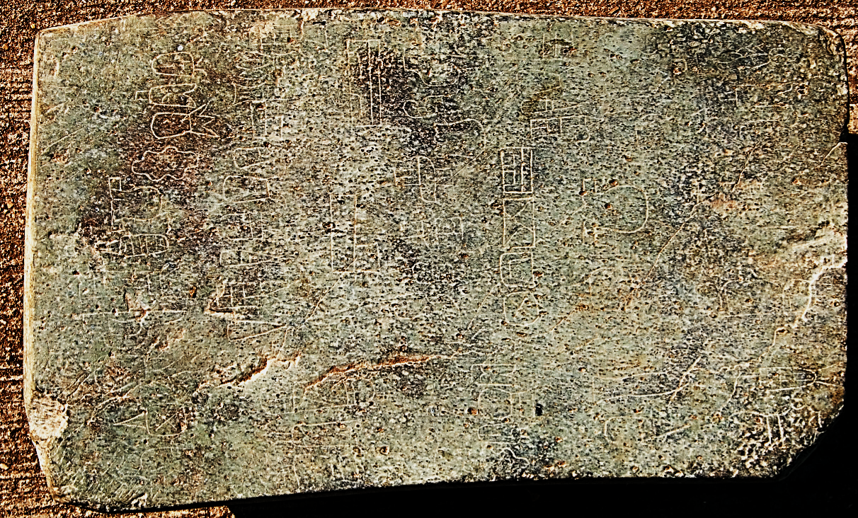

22. Supporting Online Material www.sciencemag.org/cgi/content/full/313/5793/1610/DC1 Materials and Methods Figs. S1 to S3 19 June 2006; accepted 8 August 2006 10.1126/science.1131492

**Appendix:**

The block was discovered in the late 1990s by construction workers building a road. They found it in a pile of debris in the village of Lomas de Tacamichapa in the Veracruz lowlands, an area which has been considered the heart of ancient Olmec territory. It was found amidst pottery shards and clay figurines.

While there has been substantial research on the block, there have been legitimate concerns over its veracity, some archaeologists going so far as to suggest the block is nothing more than a practical joke. For one, it was literally found in a pile of bulldozer debris and has not been reliably dated; only indirectly dated by some of the other debris it was found with. For two, some claim there aren’t any other known examples of Olmec writing or drawing, and certainly none that exist on a serpentine stone slab. For three, one of the glyphs, described unappealingly as “the cootie glyph” (it seems to depict a bug) matches no known category of Mesoamerican glyph, writing, or art style.

However, these remarks have also been met with rebuttals. There have been many major unceremonious archaeological finds, and discovery-by-accident does not necessarily invalidate the discovery itself. Moreover, because of how faint the inscriptions are, they may have eroded off other tablets and pieces due to weathering and are yet undiscovered. And finally, perhaps hilariously, the so-called “cootie glyph” can in fact be seen on another Olmec artefact. Perhaps the most famous: the San Lorenzo Monument.

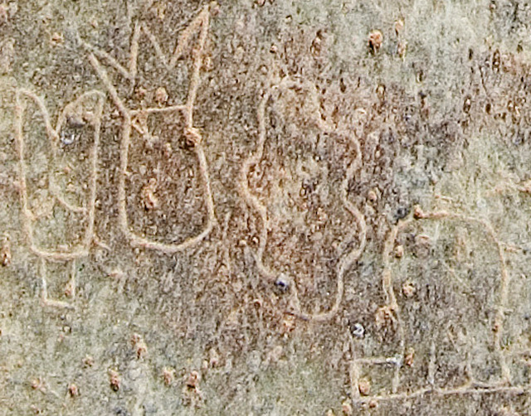

[The Cascajal Block](https://theoldstone.tumblr.com/tagged/The-Cascajal-Block) [Mexico](https://theoldstone.tumblr.com/tagged/Mexico) [Olmec](https://theoldstone.tumblr.com/tagged/Olmec) [Ancient Civilizations](https://theoldstone.tumblr.com/tagged/Ancient-Civilizations)[Mesoamerica](https://theoldstone.tumblr.com/tagged/Mesoamerica) [ancient writing](https://theoldstone.tumblr.com/tagged/ancient-writing) [writing](https://theoldstone.tumblr.com/tagged/writing) [glyphs](https://theoldstone.tumblr.com/tagged/glyphs) [serpentinite](https://theoldstone.tumblr.com/tagged/serpentinite) [stone](https://theoldstone.tumblr.com/tagged/stone)[rock](https://theoldstone.tumblr.com/tagged/rock) [tablet](https://theoldstone.tumblr.com/tagged/tablet) [stone tablet](https://theoldstone.tumblr.com/tagged/stone-tablet)

[**24 notes**](https://theoldstone.tumblr.com/post/144456834570/the-cascajal-block#notes) [May 16th, 2016](https://theoldstone.tumblr.com/post/144456834570/the-cascajal-block)

\ 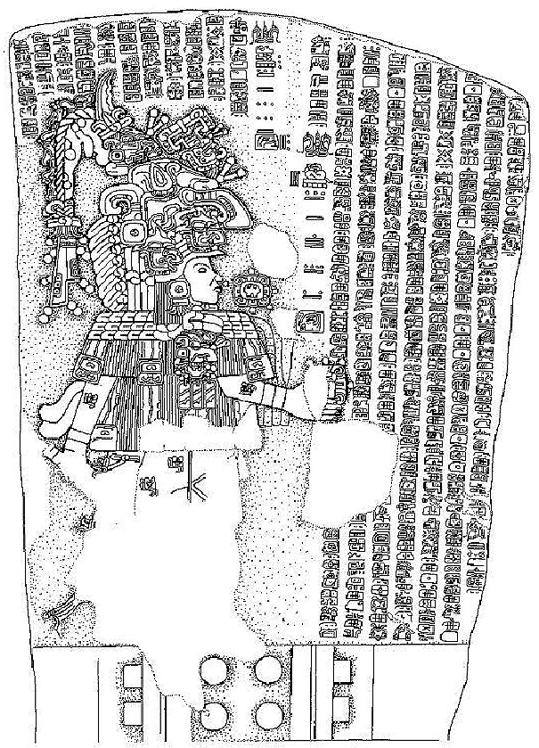

**The La Majorra Stela (1)** is one of the more recent discoveries out of Mesoamerica. First discovered in 1986, having been pulled from the Acula River in Mexico, this limestone stela from the 2nd Century CE contain over 500 glyphs of Isthmian script, one of the regions first known forms of writing. It records the ascension of a ruler named “Harvester Mountain Lord” and his achievements, but also puts them in a cosmological context, fitting his accomplishments in a calendar of observable astronomical events such as eclipses or comet sightings.

The stela is 1.4 meters wide and 2 meters tall, weighing close to 4 tons. It prominently features “Harvester Mountain Lord” as a man with an elaborate headdress and costume. Interpretations of his depiction vary. Part of the headdress forms a complicated hook-billed bird creature, which could tie to a principal bird diety, a common motif particularly amongst the early Mayans. However, from that same bird’s nose there seems to be a shark or large fish, comprising of another large portion of the headdress. This has been identified as a “shark monster” typical of the Olmec, and is an image often used to denote a ruler or monarch.

All that considered, initial efforts at translating some of the text didn’t start until 1997. Amongst the glyphs there are two symbols that are found in the Mesoamerican Long Count calendar which correspond to May of 143 CE and July of 156 CE. These two dates came to be common commemoration dates of various Mayan rules, which we know by virtue of having other artefacts that support this. The meaning of the other glyphs, however, are still largely up for debate, and won’t likely be figured out unless other archaeological discoveries are made. Presently, one translation believes the glyphs describe The Harvester Mountain Lord’s ascension as it coincided with a solar eclipse. It also describes various apprearances of Venus in the night sky, various wars, and attempted coup-d’états, a human sacrifice, and The Harvester Mountain Lord’s various blood-letting ceremonies.

[La Majorra Stele](https://theoldstone.tumblr.com/tagged/La-Majorra-Stele) [Mesoamerica](https://theoldstone.tumblr.com/tagged/Mesoamerica) [Mexico](https://theoldstone.tumblr.com/tagged/Mexico) [Acula River](https://theoldstone.tumblr.com/tagged/Acula-River) [Isthmian script](https://theoldstone.tumblr.com/tagged/Isthmian-script)[Maya](https://theoldstone.tumblr.com/tagged/Maya) [Mayan](https://theoldstone.tumblr.com/tagged/Mayan) [Long Count Calendar](https://theoldstone.tumblr.com/tagged/Long-Count-Calendar) [The Harvester Moutain Lord](https://theoldstone.tumblr.com/tagged/The-Harvester-Moutain-Lord)[Principal Bird Diety](https://theoldstone.tumblr.com/tagged/Principal-Bird-Diety) [Shark Monster](https://theoldstone.tumblr.com/tagged/Shark-Monster) [Olmec](https://theoldstone.tumblr.com/tagged/Olmec) [stones](https://theoldstone.tumblr.com/tagged/stones) [rocks](https://theoldstone.tumblr.com/tagged/rocks) [stela](https://theoldstone.tumblr.com/tagged/stela)[stele](https://theoldstone.tumblr.com/tagged/stele) [stelae](https://theoldstone.tumblr.com/tagged/stelae)

[**7 notes**](https://theoldstone.tumblr.com/post/149655480807/the-la-majorra-stela-1-is-one-of-the-more-recent?is_related_post=1#notes)

[ancientcentralamerica](http://ancientcentralamerica.tumblr.com/post/140319373412/coolartefact-os-teotihuacan-style-mask-with)

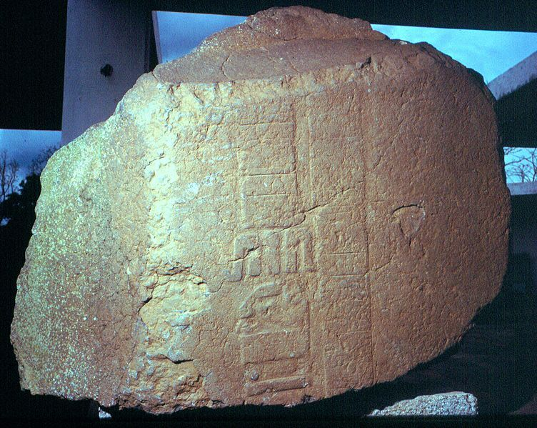 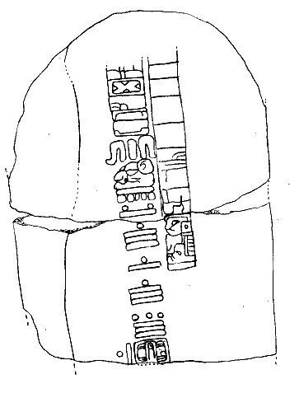

**Stela C of the Tres Zapotes archaeological site** is a stela with the oldest Mesoamerican Long Count calendar date yet unearthed. The date in question is 7.16.6.16.18, which correlates in our present-day calendar to September 3, 32 BCE.

The stela was discovered by archaeologist Matthew Stirling at the Tres Zapotes site in 1939. It is carved from basalt, with one side featuring an engraved figure of a half-man-half-jaguar, or “were-jaguar” as its been sometimes put, sitting on a throne. It is one of the few remaining examples of Epi-Olmec script, also known as Isthmian script.

It’s also important to note that the Tres Zapotes archaeological site, locate in the lowlands of Mexico near the Papalopan River, is one of the largest Olmec cities known to have existed and is rich with artefacts about this culture. Moreover, the city of Tres Zapotes itself existed as a cultural centre for the Olmec civilization of 2000 years, which in itself is unique for what we know of ancient Mesoamerica.

[ancientcentralamerica:
“ coolartefact:
“ [OS] Teotihuacan-style mask with Isthmian or Epi-Olmec writing. Possibly 350 to 650 AD [1575x1575]
Source: http://www.mesoweb.com/reports/media/isthmian_mask_back.jpg
”
Not Central American, but still...](https://theoldstone.tumblr.com/image/151671394031)



**coolartefact**

[OS] Teotihuacan-style mask with Isthmian or Epi-Olmec writing. Possibly 350 to 650 AD [1575x1575]

Source: [http://www.mesoweb.com/reports/media/isthmian\_mask\_back.jpg](https://t.umblr.com/redirect?z=http%3A%2F%2Fwww.mesoweb.com%2Freports%2Fmedia%2Fisthmian_mask_back.jpg&t=MzhiZTk2MmQ5NGM4ZjI2OWZjMjIxMTM3MTlmODBlN2U3ZjQwODc1NixTbGhsNjI4UA%3D%3D&b=t%3A_Bz8B8xlvsF55OdKucXKCg&p=https%3A%2F%2Ftheoldstone.tumblr.com%2Fpost%2F151671394031%2Fancientcentralamerica-coolartefact-os&m=1)

[](http://ancientcentralamerica.tumblr.com/post/140319373412)

**[ancientcentralamerica](http://ancientcentralamerica.tumblr.com/post/140319373412" \t "_blank)**

Not Central American, but still relevant. Teotihuacan had contact and traded with Central America. It’s important to acknowledge that ancient Pre-Columbian cultures did NOT live in bubbles, they always traded with each other and traveled long-distances to acquire and exchange goods.

This is really cool and amazing!! I’ve never see this type of writing before!

[mexico](https://theoldstone.tumblr.com/tagged/mexico) [mesoamerica](https://theoldstone.tumblr.com/tagged/mesoamerica) [teotihuacan](https://theoldstone.tumblr.com/tagged/teotihuacan) [glyphs](https://theoldstone.tumblr.com/tagged/glyphs) [epi-olmec](https://theoldstone.tumblr.com/tagged/epi-olmec)

[**86 notes**](https://theoldstone.tumblr.com/post/151671394031/ancientcentralamerica-coolartefact-os?is_related_post=1#notes)

[archaeoart](http://archaeoart.tumblr.com/post/138676249357/olmec-head-veracruz-mexico-circa-1938)

[archaeoart:
“ Olmec head, Veracruz, Mexico, circa 1938.
”](https://theoldstone.tumblr.com/image/145422185923)

[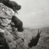](http://archaeoart.tumblr.com/post/138676249357)

**[archaeoart](http://archaeoart.tumblr.com/post/138676249357" \t "_blank)**

*Olmec head, Veracruz, Mexico, circa 1938.*

[Olmec](https://theoldstone.tumblr.com/tagged/Olmec) [Olmec head](https://theoldstone.tumblr.com/tagged/Olmec-head) [megalith](https://theoldstone.tumblr.com/tagged/megalith) [mexico](https://theoldstone.tumblr.com/tagged/mexico) [mesoamerica](https://theoldstone.tumblr.com/tagged/mesoamerica) [rocks](https://theoldstone.tumblr.com/tagged/rocks)[stones](https://theoldstone.tumblr.com/tagged/stones)

[**2,391 notes**](https://theoldstone.tumblr.com/post/145422185923/archaeoart-olmec-head-veracruz-mexico-circa?is_related_post=1#notes)

**Izapa Stela 5**, perhaps better known as the “Tree of Life” stone, was discovered and documented by Matthew Sterling in 1941 and is one of several large stela found in the ancient Mesoamerican site of Izapa, in Chiapas, Mexico beside the Guatemalan border. The stelae are dated to be from 300 BCE to 50 BCE, but there is still some argument over their precise age.

The stela is carved from volcanic andesite and weighs 1.5 tons. It offers the most complex and intricate carvings and imagery of all the stelae found at Izapa. It features at least 12 human figures, several different animals, over 25 plants and inanimate objects, and 9 different deity masks. All told, it’s presently believe to illustrate the Mesoamerican creation myth, and is thus considering both mythological and religious in nature and appears to have a narrative structure.

Mesoamerican researchers further identify the central image as a “world tree” which connects the sky, the water, and the underground. There are two main interpretations of the stone, however. One suggests that the human figures are emerging from a whole in the tree, and are then “completed” by the various other figures. The second suggestions the seated figures are ancient Izapa elites, conducting rituals and framing them in the context of divine creation.

[Izapa 5 Stela](https://theoldstone.tumblr.com/tagged/Izapa-5-Stela) [Mesoamerica](https://theoldstone.tumblr.com/tagged/Mesoamerica) [Olmec](https://theoldstone.tumblr.com/tagged/Olmec) [Tree of life](https://theoldstone.tumblr.com/tagged/Tree-of-life) [Matthew Sterling](https://theoldstone.tumblr.com/tagged/Matthew-Sterling)[1941](https://theoldstone.tumblr.com/tagged/1941) [Izapa](https://theoldstone.tumblr.com/tagged/Izapa) [Chiapas](https://theoldstone.tumblr.com/tagged/Chiapas) [Guatemala](https://theoldstone.tumblr.com/tagged/Guatemala) [volcanic andesite](https://theoldstone.tumblr.com/tagged/volcanic-andesite) [andesite](https://theoldstone.tumblr.com/tagged/andesite)[creation myth](https://theoldstone.tumblr.com/tagged/creation-myth) [stones](https://theoldstone.tumblr.com/tagged/stones) [rocks](https://theoldstone.tumblr.com/tagged/rocks) [Mexico](https://theoldstone.tumblr.com/tagged/Mexico)

[**10 notes**](https://theoldstone.tumblr.com/post/149842359512/izapa-stela-5-perhaps-better-known-as-the-tree?is_related_post=1#notes)

[theancientwayoflife](https://theancientwayoflife.tumblr.com/post/163432491220/hand-shaped-stamp-place-of-origin-mexico)

[theancientwayoflife:
“~ Hand-Shaped Stamp.
Place of origin: Mexico, Puebla, Las Bocas
Culture: Olmec
Date: 1000-600 B.C.
Medium: Slip-painted ceramic.
”](https://theoldstone.tumblr.com/image/164408534903)

[](http://theancientwayoflife.tumblr.com/post/163432491220)

**[theancientwayoflife](http://theancientwayoflife.tumblr.com/post/163432491220" \t "_blank)**

~ Hand-Shaped Stamp.  
Place of origin: Mexico, Puebla, Las Bocas  
Culture: Olmec   
Date: 1000-600 B.C.  
Medium: Slip-painted ceramic.

[Source: collections.lacma.org](https://t.umblr.com/redirect?z=http%3A%2F%2Fcollections.lacma.org%2Fnode%2F248095&t=NzZhYzQ5YzE0YTk4MDdlMWY1Yjc0NmVjOGM3MzJjYjc2NmE1ZDdkNCwxNjQ0MDg1MzQ5MDM%3D&b=t%3A_Bz8B8xlvsF55OdKucXKCg&p=https%3A%2F%2Ftheoldstone.tumblr.com%2Fpost%2F164408534903%2Ftheancientwayoflife-hand-shaped-stamp-place&m=1) [stamp](https://theoldstone.tumblr.com/tagged/stamp) [hands](https://theoldstone.tumblr.com/tagged/hands) [mexico](https://theoldstone.tumblr.com/tagged/mexico) [olmec](https://theoldstone.tumblr.com/tagged/olmec)[ceramic](https://theoldstone.tumblr.com/tagged/ceramic)

[**201 notes**](https://theoldstone.tumblr.com/post/164408534903/theancientwayoflife-hand-shaped-stamp-place?is_related_post=1#notes)

**Stela C of the Tres Zapotes archaeological site** is a stela with the oldest Mesoamerican Long Count calendar date yet unearthed. The date in question is 7.16.6.16.18, which correlates in our present-day calendar to September 3, 32 BCE.

The stela was discovered by archaeologist Matthew Stirling at the Tres Zapotes site in 1939. It is carved from basalt, with one side featuring an engraved figure of a half-man-half-jaguar, or “were-jaguar” as its been sometimes put, sitting on a throne. It is one of the few remaining examples of Epi-Olmec script, also known as Isthmian script.

It’s also important to note that the Tres Zapotes archaeological site, locate in the lowlands of Mexico near the Papalopan River, is one of the largest Olmec cities known to have existed and is rich with artefacts about this culture. Moreover, the city of Tres Zapotes itself existed as a cultural centre for the Olmec civilization of 2000 years, which in itself is unique for what we know of ancient Mesoamerica.